Freight Rate Prediction - Technical Summary

Approach
The data was explored for missing values, categorical variables, numerical features, date effects, and unusual observations. Since the prediction task has a time-series structure, validation was performed using a time-based train/test split rather than a random split.
The data was first sorted chronologically by date and then divided into 80% training data and 20% testing/validation data. The first 80% of the observations in time order were used for training, while the most recent 20% were held out for validation. This approach better represents the real prediction setting, where the model is trained on historical data and then used to predict future observations. A random split was avoided because it could allow information from later dates to influence the training set and produce an overly optimistic estimate of performance.
As part of data cleaning, negative values in features where they are not physically meaningful were treated as missing (NaN) and handled using the same imputation strategy as other missing values. For example, weight cannot be negative in a real-world freight shipment. Although a machine-learning model can technically process negative values, allowing physically impossible values could introduce misleading patterns and reduce the practical reliability of the model. This step therefore ensures that the input data remains consistent with real-world constraints.
For missing weight, the global median was used. Weight showed a clear upper cap with many observations concentrated at the maximum, so using the mean could be biased upward.
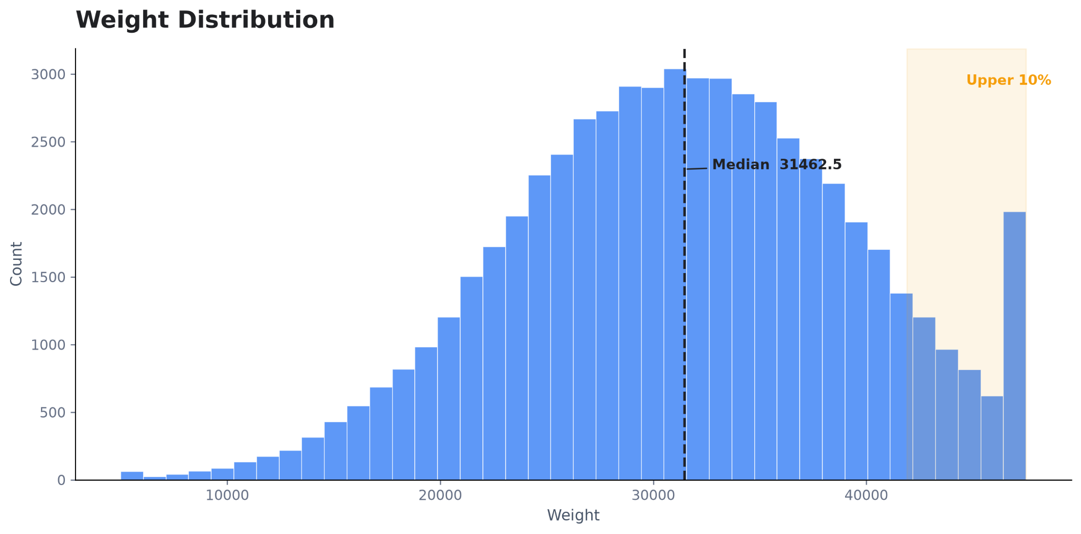
For market index, the median by date was used when historical observations for that date were available. Within a date, the index varied only slightly, making the daily median a robust estimate.
We also tested whether the market index could be estimated when a date had no market-index observations. The index showed a strong recurring day-of-week pattern plus a gradual time trend. This pattern was also visible in December, where the weekly level gradually increased while the same weekly shape repeated.
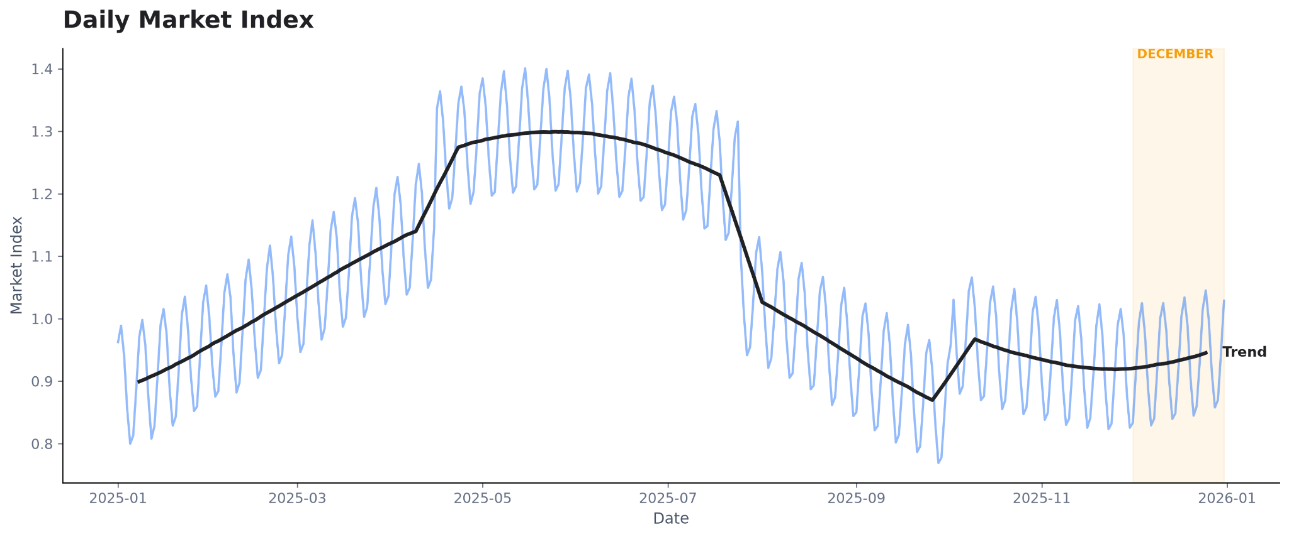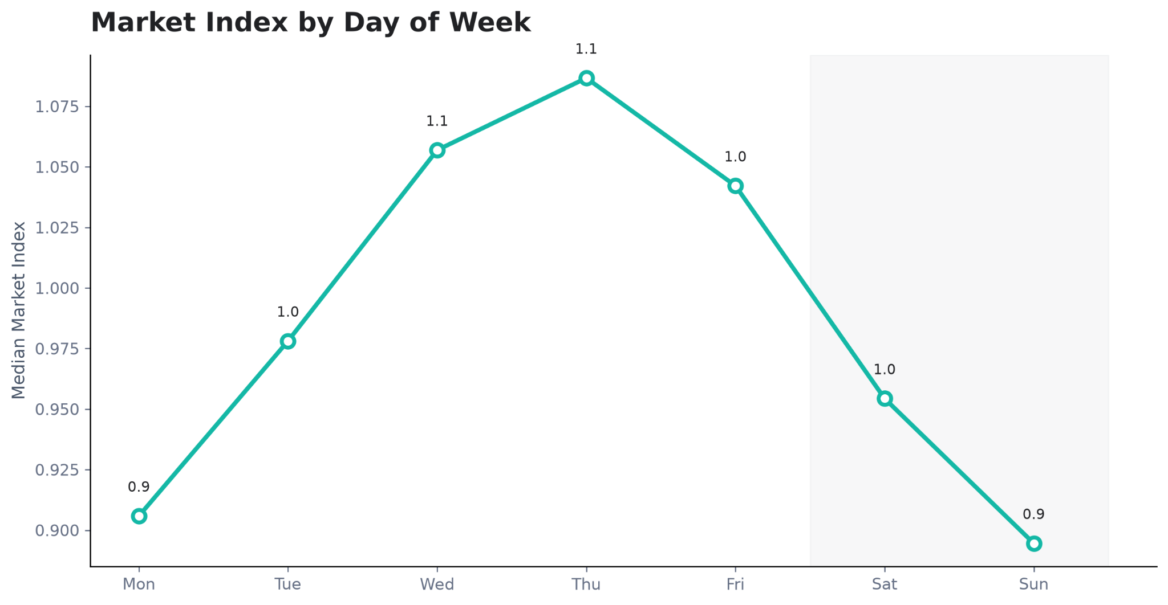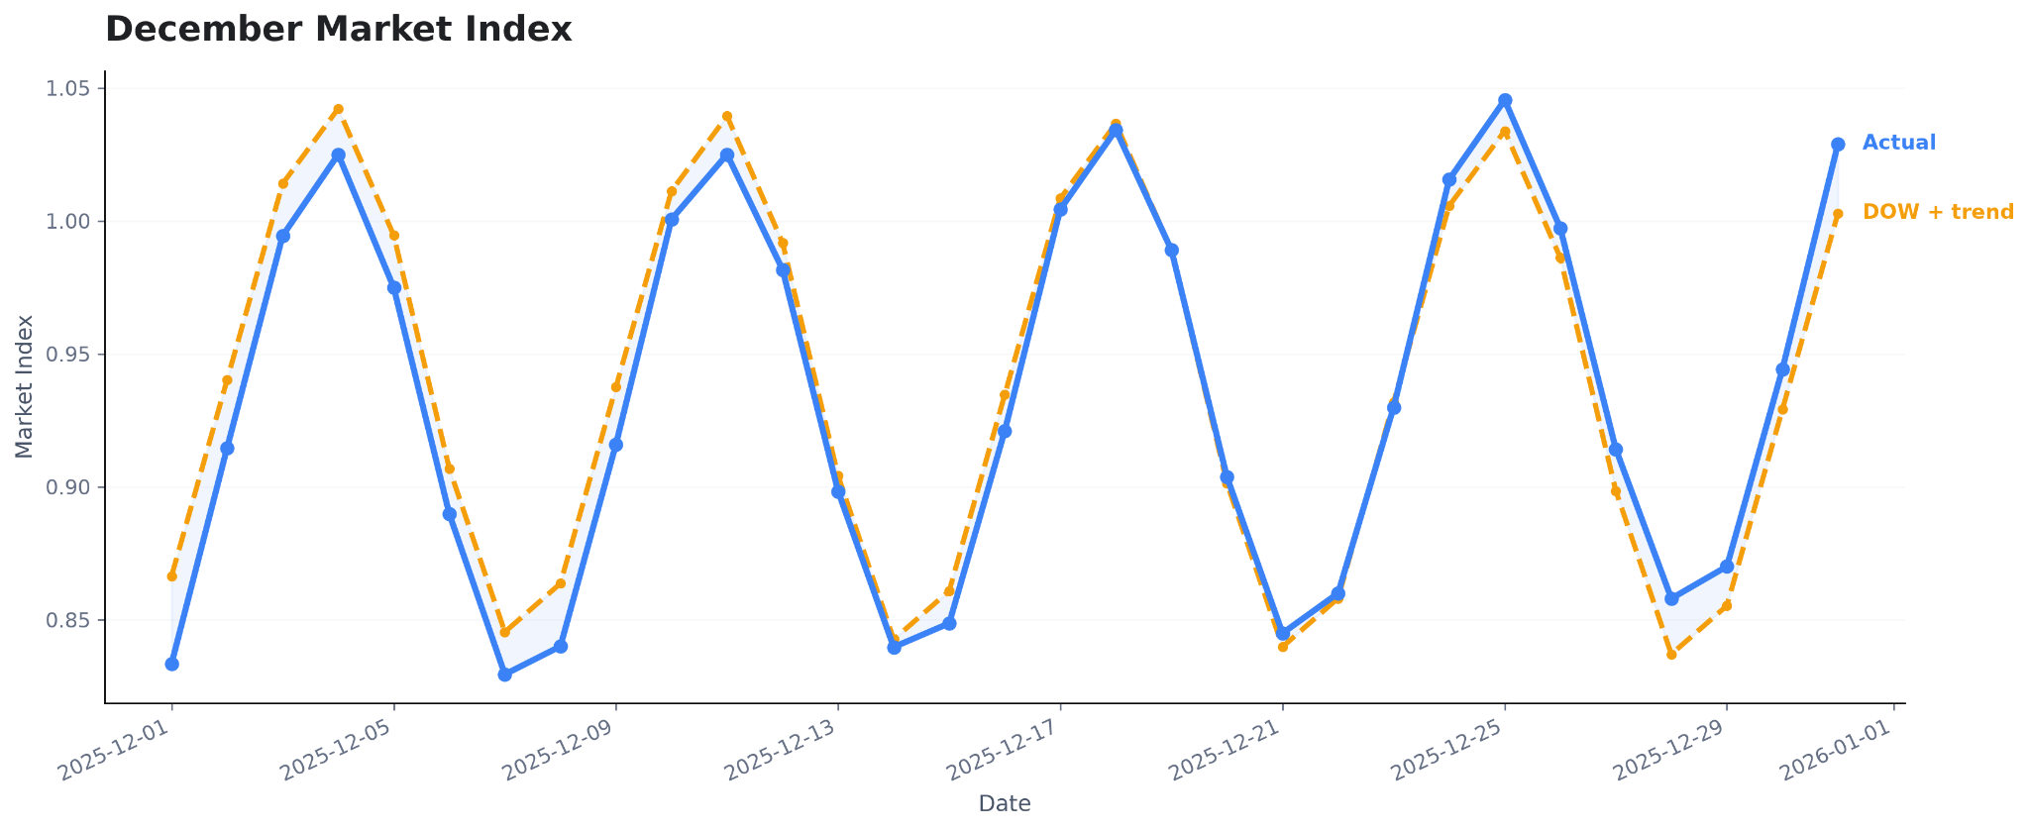

Model Selection
Several feature/model combinations were tested. One-hot encoding performed better than target encoding for categorical features. An MLP-based model performed better than the tested LightGBM alternative on the chosen time-based validation setup.
The final model was selected based on validation performance rather than trying to maximize performance on a single experiment. The model choice is therefore specific to the structure of this dataset and prediction objective, rather than a claim that MLP or one-hot encoding is universally superior.

Data Quality and Exceptional Cases
We also experimented with removing approximately 35-40 extreme observations. These observations had unusually high posted rates/rates-per-mile, and removing them substantially improved normal-regime validation performance.
This suggests the model fits the normal pricing regime well, while some exceptional loads contain information that is not available in the provided features. For example, an unusually expensive load could represent an urgent shipment or another operational circumstance that is not explicitly recorded.
Therefore, these observations should not simply be removed from the final training data because they are possible real outcomes. Instead, predictions in this region should be monitored and potentially flagged as anomalies for review.

December Analysis
The December chart inputs contain the same fixed route, distance, equipment, and weight, with the date being the changing variable. The predicted December curve therefore primarily reflects the estimated market-index/date pattern.
The scorer-generated December chart shows approximately four repeating weekly peaks/valleys. This is consistent with the observed market-index behaviour: the within-week shape repeats closely, while the weekly level gradually changes through December.
The final solution therefore uses the discovered temporal structure rather than treating December as an arbitrary collection of independent dates.
